Question 42 Answers

Part 1.

* The associations should not have any text on them.
* The stereotypes should only say ‘extend’ or ‘include’ on them.
* The ‘extend’ stereotypes should have a directed dashed arrow from the additional functionality to the original use case. E.g. extend pointing from **order coke** to **order food**
* There is an association between **pay for food** and **withdrew money from ATM** where it should be a stereotype.
* **Order food** to the customer has a directional arrow where it should just be a line.
* The stereotype between **pay for food** and **pay for coke** needs a directional arrow.
* **Prepare dinner** isn’t associated with any user.
* The extends for ordering/serving food and coke should be includes because it is similar behaviour rather than an original complete use case.
* Combine **pay for coke** and **pay for food** because they are all payed for in the same bill, no separate process for paying for each.
* **Prepare dinner** should be renamed **prepare food** to be consistent.
* Should be **Withdraw** rather than **Withdrew** as it should all be in present tense.

Part 2.

PTO.

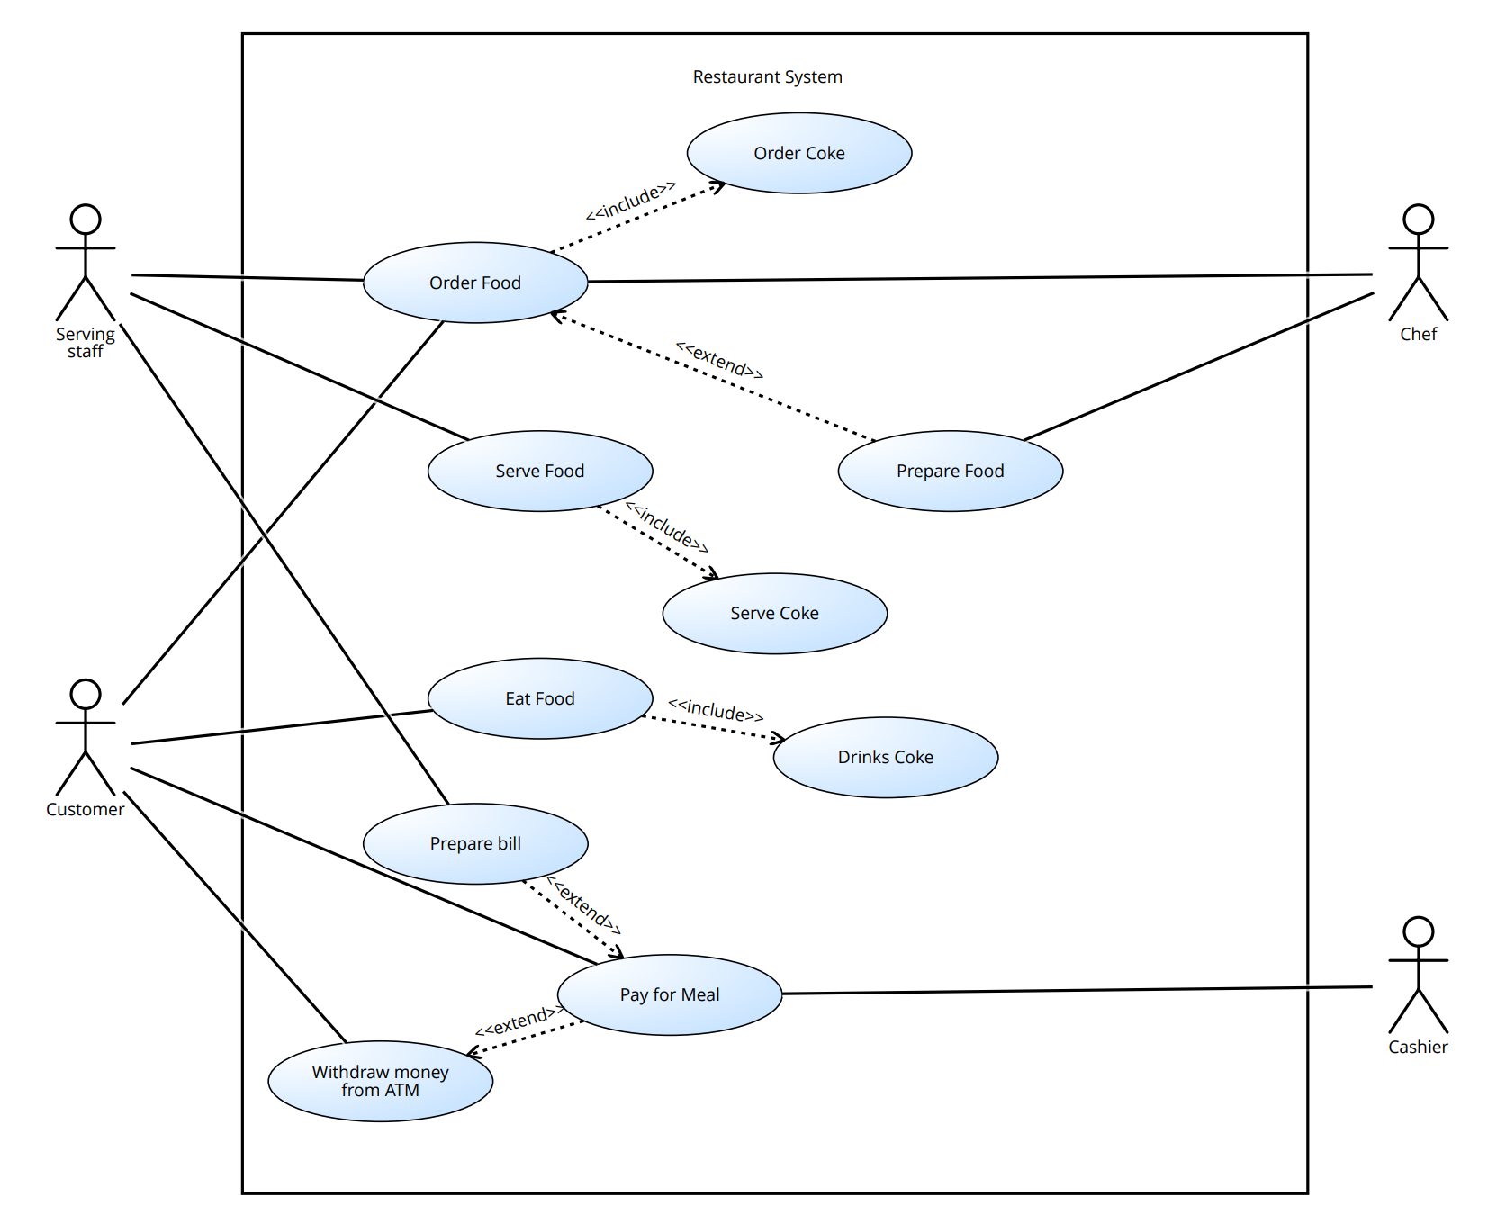

[if coke was ordered]

[if coke was served]